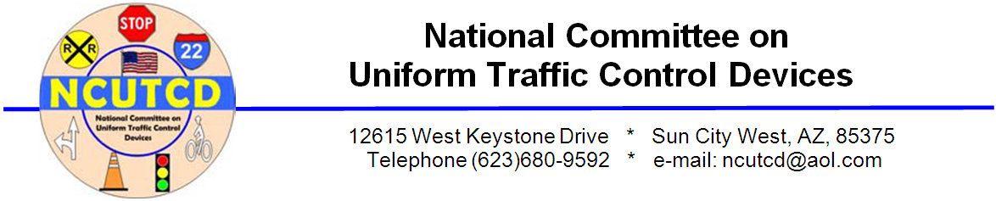

NOTE: The Rules of the Road Committee (RORC) was created by the Executive Committee as an adhoc committee of the NCUTCD to address changes the “Rules of the Road” of the Uniform Vehicle Code (UVC). This occurred because the National Committee on Uniform Traffic Laws and Ordinances (NCUTLO) went into hiatus pending a viable funding source in June of 2009. This left a void that the NCUTCD believes needs to be filled, and no other technical or professional group came forward to fund such an activity. Even copies of the previous UVC are no longer available to provide guidance on such model laws and rules to States and local governments. As individual changes are proposed and approved by sponsors and the NCUTCD, they will be posted on the NCUTCD web site as recommendations of the Committee. The recommendations are not part of the MUTCD and as such have no status with the FHWA.

The RORC contains representatives of each of the Technical Committees.

COMMITTEE OF ORIGIN: Rules of the Road Committee (RORC)

STATUS/DATE OF ACTION: Send for Sponsor Comments

TOPIC: Prohibiting texting

RORC Approval: _____, 2012

Transmitted to Sponsors: _____, 2012

Council Approval: _____, 2012

ORIGIN OF REQUEST: John S. Allen, Bicycle Technical Committee member

AFFECTED SECTIONS OF UVC 11-(New section)

SUMMARY:

This change would prohibit sending or receiving text messages while operating a vehicle

DISCUSSION:RECOMMENDED CHANGES TO “RULES OF THE ROAD, UVC”

Operation of a vehicle while sending or reading a text message is proving to be a serious hazard. 37 states, the District of Columbia and Guam have already banned texting for all drivers, see http://www.ghsa.org/html/stateinfo/laws/cellphone_laws.html. The following wording is from California section 23123.5, see http://www.dmv.ca.gov/pubs/vctop/d11/vc23123_5.htm

§ 11-***-Texting
- A person shall not drive a vehicle while using an electronic wireless communications device to write, send, or read a text-based communication.
- As used in this section “write, send, or read a text-based communication” means using an electronic wireless communications device to manually communicate with any person using a text-based communication, including, but not limited to, communications referred to as a text message, instant message, or electronic mail.
- For purposes of this section, a person shall not be deemed to be writing, reading, or sending a text-based communication if the person reads, selects, or enters a telephone number or name in an electronic wireless communications device for the purpose of making or receiving a telephone call.
- This section does not apply to an emergency services professional using an electronic wireless communications device while operating an authorized emergency vehicle, in the course and scope of his or her duties.

VOTE: ____ For, ____ Against, ___ Abstentions

